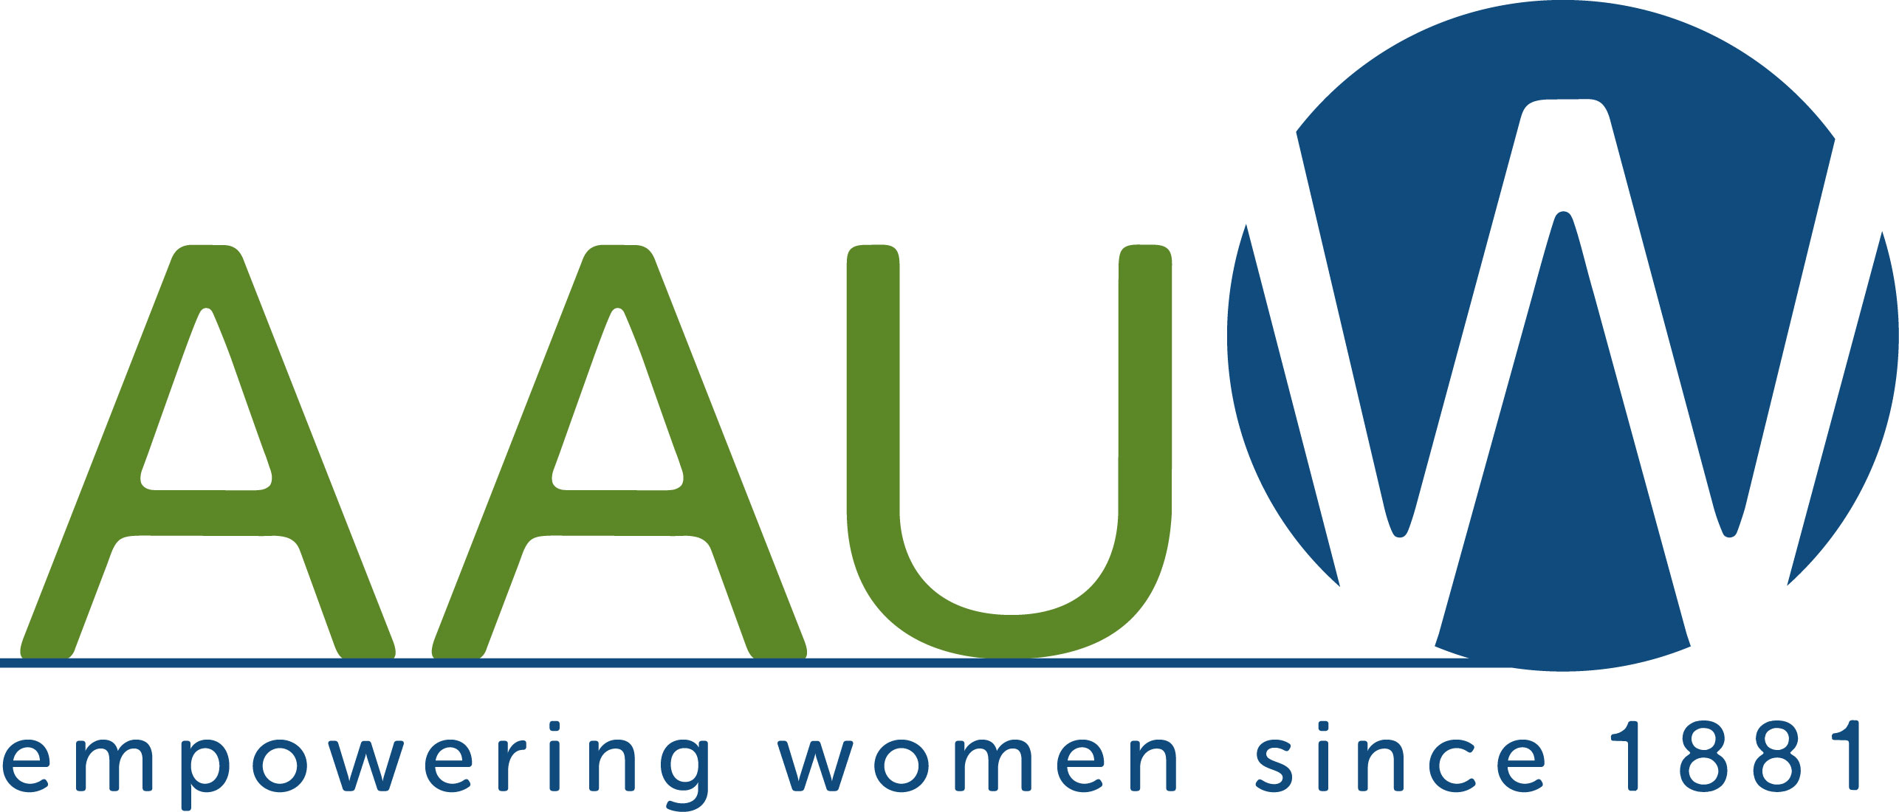
March 2022

(Business Name Here)

Dear (Contact Name Here),

We, the 175 members of the Colorado Springs American Association of University Women, are requesting your support for our AAUW Scholarship Fundraiser which supports scholarships for deserving local women enrolled in Pikes Peak area colleges. Your donation of a gift card, merchandise, or money to our Silent Auction on April 30, not only supports these women of promise, but brings your business welcome exposure to our members and others in the community through our website and social media

What is AAUW? The American Association of University Women is the nation’s leading voice in promoting equity and education for women and girls. Our mission is to advance gender equality through research, education, and advocacy. Our Colorado Springs branch supports this mission by raising funds to provide scholarships for UCCS and PPCC to local women of high potential but limited financial means.

Your business will benefit from this donation in several ways. AAUW is a 501(c)3 organization, so your donation is tax deductible. Our tax ID# is 84-3789955, and we can provide you with an IRS receipt. Additionally, your company name/logo will be prominently placed on auction publicity materials and program. Your business will be recognized in our monthly newsletter and on our website https://coloradosprings-co.aauw.net.

We are your customers and neighbors, and we appreciate your support.
We are happy to support your business as well!

Sincerely,

Cindi Zenkert-Strange
President Elect, Fundraising Chair
AAUW Colorado Springs Branch

(Or your name and signature)

