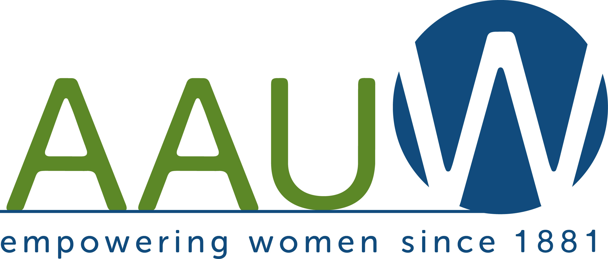
March 2021

(Business Name Here)

Dear (Contact Name Here),

We, the 220 Colorado Springs members of the American Association of University Women, ask for your support of our AAUW Scholarship Fundraiser for local women to achieve their goal of a college education. Your donation of a gift card, merchandise or money to our virtual Silent Auction running from April 2 to 16 brings you welcome exposure to our members and to all who visit our website.

What is AAUW? The American Association of University Women is the nation’s leading voice in promoting equity and education for women and girls. Our mission is to advance gender equality through research, education, and advocacy. Our Colorado Springs branch supports this mission by raising funds to provide scholarships for UCCS and PPCC to local women of high potential but limited financial means.

Your business will benefit from this donation in several ways. AAUW is a 501(c)3 organization, so your donation is tax deductible. Our tax ID# is 84-3789955, and we can provide you with an IRS receipt. Additionally, your company name/logo will be prominently placed on our 32 Auctions website for the duration of the auction. Recognition in our monthly newsletter to our members and on our website is yours also: https://coloradosprings-co.aauw.net.

We are your customers and neighbors, and we appreciate your support.
We are happy to support your business as well!

Sincerely,

Pip Bodkin
President Elect, Co-Chair, Fundraising
AAUW Colorado Springs Branch

(Or your name and signature)

